Game #1 –Team Name (Coach) vs. Team Name (Coach) …(We are AWAY team…so we bat first / field last)
Remember! | - Hitting – Run through 1st base | - Fielding - Know what to do BEFORE the ball is hit | - Outfield -Get rid of the ball as fast as you can
Next Up:  - Baseball Game on [Date]  - Baseball Game on [Date]  Baseball Homework:  - Play catch with a sibling or parent before next game  - Swing a bat 50 times before next game | 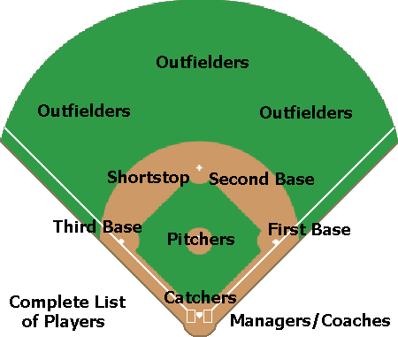
Batting Order | 1st Inning | 2nd Inning | 3rd Inning | 4th Inning | 5th Inning
Player 1 | 3rd Base | 3rd Base | Catcher | Left Field | Left Field
Player 2 | LC Field | LC Field | Left Field | RC Field | 2nd Base
Player 3 | Catcher | Catcher | RC Field | Short Stop | Short Stop
Player 4 | Left Field | Left Field | 3rd Base | 3rd Base | RC Field
Player 5 | 2nd Base | 2nd Base | Right Field | Right Field | Right Field
Player 6 | 1st Base | 1st Base | 1st Base | Catcher | 3rd Base
Player 7 | Short Stop | Short Stop | Short Stop | 1st Base | 1st Base
Player 8 | RC Field | RC Field | 2nd Base | 2nd Base | Pitcher
Player 9 | Pitcher | Pitcher | LC Field | LC Field | LC Field
Player 10 | Right Field | Right Field | Pitcher | Pitcher | Catcher

